The PowerPoint presentation – despite its shortcoming – is the vehicle of choice for information sharing among many businesses. R bring unparalleled power to data analysis and visualization. But getting those visualizations from the display window in R Studio to a formatted slide via copy/paste is tedious and error prone.

Good news, there’s a better way. **R Markdown automates the creation of presentation-worthy slides from R code.** This feature can save hours of time, eliminate errors, and allow a user to update the information a two-hundred-page slide deck with the touch of a button. This is key for decks that include state-by-state data, profit margins across dozens of product lines, or complex visualizations reliant on constantly updated data.

In this presentation we use data on COVID-19 infections provided by the *New York Times* and updated daily. The code allows users to get the latest statistics by state in a formatted PowerPoint deck instantly. Check out the code on Github along with the outputs.

We will walk through four keys to creating a presentation:

1. How to create a title slide
2. How to create a full-page element, in this case a nicely formatted table
3. How to create a Powerpoint slide with two side-by-side elements
4. How to crack into the PowerPoint template file for advanced formatting

# Title slide

This tutorial assumes some familiarity with R, R Studio, and R Markdown. If you’ve ever used R Markdown to output an HTML file or a PDF, the format will look very familiar. Simply change the output in the header to powerpoint_presentation.

Here we’ve also added `r Sys.Date()` will show the current date and added a PASS Template:

# Full page table

R libraries 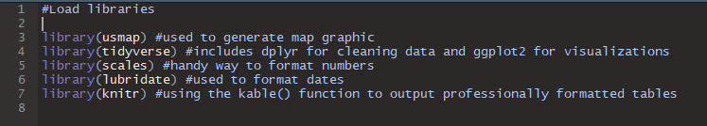

Load data from the New York Times Github into a data frame. This data

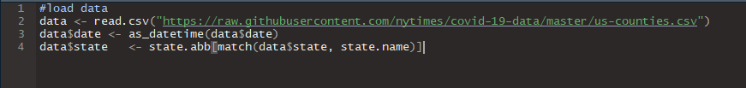

Use DPLR to output the table. We’re using the kable() function to output a professionally formatted table. Per R Markdown [include cheat sheet], a hash tag preceding text creates a slide title. The \

# States most impacted by COVID-19

```{r States_overview, warning = FALSE, message = FALSE, echo=FALSE, fig.width=12}

State <- as.factor(state.name[match(data$state, state.abb)])

state_summary <- data %>%

cbind(State) %>%

group_by(State, date) %>%

summarise("Total Cases" = sum(cases), "Total Deaths" = sum(deaths)) %>%

group_by(State) %>%

summarize("Total Cases" = max(`Total Cases`),"Total Deaths" = max(`Total Deaths`)) %>%

arrange(desc(`Total Cases`)) %>%

head(15)

state_summary$`Total Cases` <- comma(state_summary$`Total Cases`)

state_summary$`Total Deaths` <- comma(state_summary$`Total Deaths`)

kable(state_summary)

```

But wait, the output runs off the page. Don’t worry, we’ll cover this in advanced formatting.

[Insert screen shot]

# Side-by-side charts

First, we need to understand the slide format. Notice the title has inline code: `r [code]`

Note the series of colons below, which denote the change In columns. The functions output a chart and a map.

# `r state.name[6]`

:::::::::::::: {.columns}

::: {.column}

```{r echo=FALSE, message=FALSE, warning=FALSE}

state_chart_function(state.abb[6])

```

:::

::: {.column}

```{r echo=FALSE,message=FALSE,warning=FALSE}

state_map_function(state.abb[6])

```

:::

::::::::::::::

# Advanced PowerPoint template editing

…